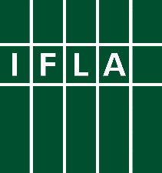
GLOBAL VISION DISCUSSION

Report of the Russian
regional self-organised meeting
How a united library field
can tackle the challenges of the future

Date: July 14th, 2017
Venue: M.I. Rudomino All-Russia State Library for Foreign Literature, Moscow, Russian Federation

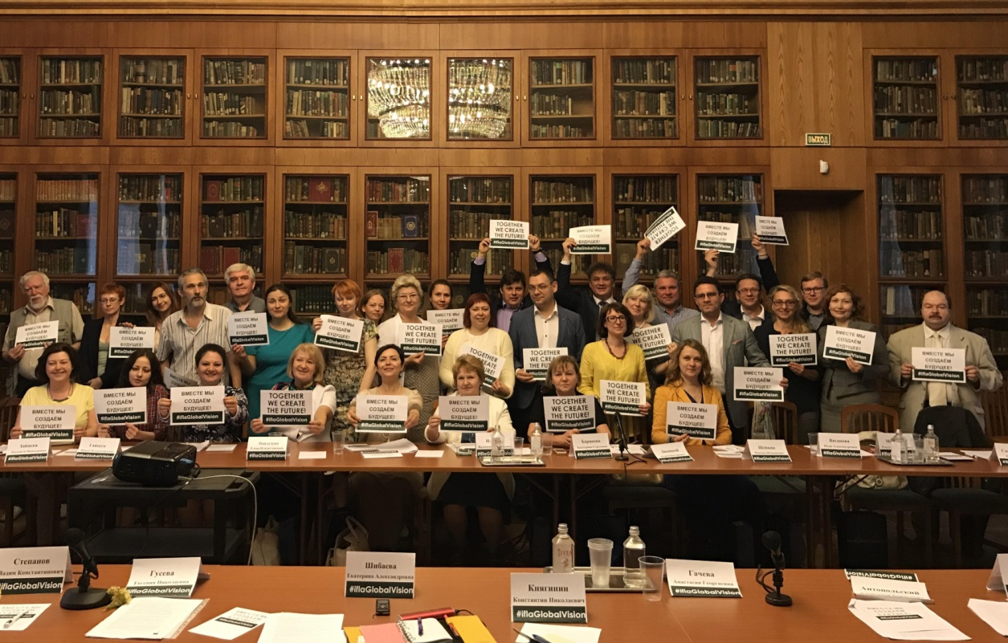

Index
Index 2
Contributors 3
Introduction 5
A vision for libraries 5
The core values of libraries (Q4): 6
Libraries are exceptionally good at (Q5): 6
Libraries should do more of (Q6): 6
Libraries should do less of (Q7): 7
Challenges and solutions 7
The main challenges to society (Q8): 7
The main challenges to libraries (Q9): 8
The main professional challenges (Q10): 8
How a united library field can make a difference 9
How should a united library field help meet the challenges identified (Q11)? 9
The characteristics of a united library field (Q12): 9
The focus of a united library field (Q13): 10
A global conversation
10

Contributors
The report was created by:
Vadim Duda, Yuriy Cherny, Svetlana Gorokhova, Liudmila Zaytseva
Translated by: Irina Gayshun, IFLA Russian Language Centre Coordinator, Russian State Library
List of Participants of the Russian regional self-organised meeting:
- Olga Andon, Head Librarian, Bogolubovo rural library (Vladimir Region), winner of the All-Russia professional contest “Librarian of the Year, 2013”
- Alexander Antopolsky, Chief Scientist, the Informatics Problems Studying Center , Institute of Scientific Information on Social Sciences of the Russian Academy of Sciences.
- Ekaterina Barinova, Chief Conservator, A.N. Nekrasov Central Universal Scientific Library
- Yuriy Cherny, Head of the Informatics Problems Studying Center, IFLA Information Technologies Section Corresponding Member, Moderator of the Russian regional meeting “IFLA Global Vision”
- Anastasia Gacheva, Excursion Department, Moscow City Library № 124, winner of the All-Russia professional contest “Librarian of the Year, 2014”
- Irina Gayshun, Deputy Head, Foreign LIS and International Relations Department, Russian State Library, IFLA Russian Language Centre Coordinator
- Svetlana Gorokhova, Head, Center for International Cooperation, M.I. Rudomino All-Russia State Library for Foreign Literature; Corresponding Member of the IFLA Continuing Professional Development and Workplace Learning Section, Moderator of the Russian regional meeting “IFLA Global Vision”
- Eugenia Guseva, Adviser to Administration, Russian State Library, member of the National Library Association “Libraries of the Future” (NALF)
- Vadim Duda, Director General, M.I. Rudomino All-Russia State Library for Foreign Literature, Vice-president of the National Library Association “Libraries of the Future” (NALF), Chair of the Russian Library Association (RLA) International Relations Section
- Irina Dzhunzhurova, Representative of the Department of Libraries, Science and Education Office, Ministry of Culture of the Russian Federation
- Galina Elfimova, Head, Editorial Department, Russian State Library for the Blind
- Valentina Iliina, Director, Library for Russian History and Philosophy “The House of A.F. Losev”
- Liubov Kazachenkova, Director General, Publishing Consulting Centre “The Modern Library”; Chief Editor, “The Modern Library” magazine
- Konstantin Knyaginin, Leading Researcher of Scientific-methodical Department, Boris Yeltsin Presidential Library
- Elena Lindeman, Deputy General Director, Russian National Public Library for Science and Technnology, Executive Director of the National Library Association «Libraries of the Future» (NALF)
- Andrei Lisitsky, Director, F.M. Dostoyevskyi Moscow City Library №19
- Irina Lisitsyna, Deputy Head, Department of Libraries, Science and Education Office, Ministry of Culture of the Russian Federation
- Khachatur Marinosyan, Academician of the Russian Academy of Natural Sciences, President of the Academy of Humanitarian Studies, Chief Editor of the magazine “Philosophic sciences”
- Olga Mashkova, Head, Media Center, A.N. Nekrasov Central Universal Scientific Library
- Olga Mezentseva, Deputy Director for Science and Publishing Activities, Russian State Children’s Library, Member of the Russian Library Association (RLA) Libraries for Children Section
- Maria Neryeva, Deputy Head, Department on Library Interaction with Russian and CIS Libraries, Executive Director of the “Library Assembly of Eurasia”, IFLA Library Services to Multicultural Populations SC Member
- Igor Novikov, Head, “The Book Club”, M.I. Rudomino All-Russia State Library for Foreign Literature, member of the Guild of Marketing Specialists of Russia, Member of the National Library Association “Libraries of the Future” (NALF)
- Rifat Sarazetdinov, Director General, limited liability company “GRAND”
- Maxim Sheinin, Deputy Head, Informatization Department, Russian State Art Library
- Ekaterina Shibaeva, Deputy Editor-in-Chief, Periodicals Department, Executive Secretary; Russian State Library; Coordinator of the Russian Library Association (RLA) “Libraries and Social media” working group
- Elena Spichkina, Director, University Library, Krasnodar State University of Culture
- Vadim Stepanov, Professor, Department of Electronic Libraries and Cultural Informatization, Moscow State Institute of Culture
- Larisa Suleimanova, Director, Irkutsk Oblast State Regional Universal Scientific Library
- Inna Vaganova, Deputy Director for Informatization, Russian State Art Library
- Ekaterina Vasilieva, Head, PR Department, Russian State Library for Young Adults
- Liudmila Zaytseva, Head of the General Planning and Reporting Department, Head of the Russian Library Association (RLA) Library Management and Marketing Section, IFLA Management and Marketing Section SC Corresponding Member, IFLA Statistics and Evaluation Section SC Member
- Tatiana Zhukova, President, Russian School Libraries Association, Board Member of the Russian Library Association (RLA)

Introduction
On July 14th 2017, in the M.I. Rudomino All-Russia State Library for Foreign Literature, Moscow, Russia, 32 librarians participated in a conversation about how a united library field can tackle the challenges of the future. Together we represent 589 years of library experience.

Russian regional meeting was organized by the M.I. Rudomino All-Russia State Library for Foreign Literature with the support of the Russian State Library and held under the aegis of two national library associations -- the Russian Library Association (RLA) and the National Library Association “Libraries of the Future” (NALF). Among 32 participants there were two winners of the All-Russia professional contest “Librarian of the Year” (2013, 2014), leaders and librarians from Moscow, Saint-Petersburg, Vladimir region, Krasnodar and Irkutsk, representatives of the Ministry of Culture of the Russian Federation, leading professional and public institutions, publishing industry and journalists. Thus, the delegates represented the interests of libraries of different types: public (national, federal, regional, municipal and rural), university, research and academic, special etc.

A vision for libraries
Libraries enable literate, informed and participative societies. When we look at the future, according to the debates in M.I. Rudomino All-Russia State Library for Foreign Literature, Moscow, Russia, this means that the rapid changes in the information environment and development of information technologies have dramatically changed the role and functions of the libraries.
From mono-dimensional hierarchy model, where the Book was on the top, as the sacral symbol of the Collection, and where all the operations were internally organised and book-centric, the Libraries shift to open, pluralistic models, where readers, users, communities and the society in general are the active participants of their development. Libraries become modern information centers, providing open (and free) access to the variety of reliable sources of information (both in digital and traditional formats), centers of multicultural communications and intellectual development fostering knowledge, creativity, dialogue, educational institutions, life-long partners in personal development.
Libraries build close ties between themselves and other related communities for effective exchange of resources, workflows, solutions, ideas and experience, developing integrated systems and working environments for effective and efficient operations.
Libraries are essential to nations, societies and communities.

The core values of libraries (Q4):

1. Provision of reliable information, legal access to content – 27 votes
2. Equal and unhampered access to information (library services free of charge), openness, neutrality - 22 votes
3. High level of competence of working with information - 20 votes
4. Focusing on meeting user needs – 20 votes
5. Comfortable conditions (facilities, equipment, physical accessibility, comfort, Internet etc) – 18 votes
Comments:
Participants identified some unique core values of libraries such as accessibility, free services and neutrality. Also, several features of modern libraries: social reputational benefits (respect and trust of users), user-oriented approach were noted.

Libraries are exceptionally good at (Q5):
1. Vast offline network of libraries – 28 votes
2. Unique resources and collections – 25 votes
3. Accessible multifunctional environment, communication centre, “third place” - 22 votes
4. Variety of high level events - 19 votes
5. Unique competencies of library staff – 17 votes
Comments:
The group highlighted a special feature of the library system in Russia, which is a vast library network (around 100 thousand libraries of different organizational affiliation), including public (around 40 thou.), school (over 30 thou.), university, research and academic, and special libraries. All these institutions have unique resources and collections, strive for wide implementation of ICTs, possess skilled staff and serve a wide range of users. Today’s libraries evolve its traditional role of information facilitators and become multifunctional centers of social communications.

Libraries should do more of (Q6):
1. Improving skills, professional and personal development of staff – 30 votes
2. Interacting with communities and users – 29 votes
3. Monitoring and meeting user needs as much as possible – 29 votes
4. Rapidly adapting to the changes in the society and ecosystem – 29 votes
5. Interacting with authorities and policy makers – 26 votes
Comments:
The experts recognized the need for strengthening library advocacy at all levels of government and public administration, interaction with other cultural, research and educational institutions, development of user feedback system, quality of customer services and marketing of services.

Libraries should do less of (Q7):
1. Doing monkey business, wasting efforts on arranging events only for events – 28 votes
2. Playing the blame game, being frustrated - 24 votes
3. Turning on each other – 22 votes
4. Being snobs in profession, having belief in its own exceptionality – 20 votes
5. Doing excessive reports -19 votes
Comments:
The participants placed a strong focus on specific features and “pressure points” of the Russian library system such as uneven provision of library services, poor intersectional coordination, commitment to outdated methods and approaches, unwillingness and fear of changes, bureaucracy, lack of initiatives and departmental disunity.

Challenges and solutions

The main challenges to society (Q8):
1. E-economy and digital technologies – 29 votes
2. Globalization, global informational and educational environment – 28 votes
3. Reduction of educational attainment and cultural level - 25 votes
4. Automated production, reduction in employment – 22 votes
5. Digital divide – 19 votes

Comments:
The participants considered the explosive growth of digital technologies, essentially changing the role of libraries in the information environment, as a key driver of changes. Also, the experts noted that there was an urgent need for revision of library success criteria in this new world considering new requirements of society.

The main challenges to libraries (Q9):
1. Intense competition in the information space – 29 votes
2. Labor shortage, problem of attracting young promising employees – 26 votes
3. Lack of social services procurement from the state and society – 22 votes
4. Declining popularity of traditional printed materials – 22 votes
5. Explosive growth of ICTs and mobile technologies – 17 votes

Comments:
The experts pointed out the priority role of libraries as vital cultural and cultural heritage institutions, intellectual, research and educational centers. There’s the risk of transforming the libraries into some leisure centers that will lead to degradation of a high level of libraries. Need for dialogue within the community for understanding and exchange also was noted.

The main professional challenges (Q10):
1. Urgent need for development of the system of professional education and flexible system of staff development - 30 votes
2. Declining attractiveness of librarianship as a profession – 27 votes
3. Mismatch between professional standards, modern working conditions and technologies development – 26 votes
4. Lack of new competencies and skills, vital for e-economy – 25 votes
5. Ageing of staff: high average age of staff, “pre-digital” mentality - 24 votes

Comments:
The experts highlighted the need for flexible meeting the changing society needs, creation of continuing professional development system, collecting best practices. The problem of lacking new library “stars” and “icons”, leaders able to build and implement the change agenda in professional education and development also figured high.

How a united library field can make a difference

How should a united library field help meet the challenges identified (Q11)?
1. We need to embrace and use new technologies in everyday working life – 28 votes
2. System of professional staff training must be reformed – 28 votes
3. We need to be engaged in a dialogue with authorities and policy makers, to develop our professional advocacy skills - 27 votes
4. We should be actively involved in the legislation and regulative activities and to ensure the harmonization of the laws in different countries and jurisdiction – 25 votes
5. To encourage users and volunteers to participate in the library activity – 25 votes
Comments:
According to the participants, the library community needs to elaborate a common development strategy and tactics, based on the laws (trends) of development of the global information environment, widely share information with each other, overcome institutional, linguistic, national and other forms of segregation — to become full members of the global library community, to learn new technologies and be ready for their widespread implementation.

The characteristics of a united library field (Q12):
1. Common goals and vision of development – 29 votes
2. Sustainable relations with the related communities - 29 votes
3. Common professional values – 27 votes
4. Coordination of efforts – 26 votes
5. Integration of the national professional community into the united world community – 25 votes

Comments:
The main characteristics of a united library field are: commitment to common professional values, ability to respond to the challenges of the time, professional solidarity and team building, development of sustainable relationships with related communities (archives, museums, publishing industries, scientific, educational and IT communities etc.), strong and high-tech network of communications and partnerships.

The focus of a united library field (Q13):
1. To develop a “Modern Library” concept – 27 votes
2. Defining and understanding the future global information environment and the role of libraries in it – 25 votes
3. Developing library strategy in the new information environment – 22 votes
4. To support development of a united digital knowledge space - 21 votes
5. Library advocacy, protection of librarians’ and users’ rights – 16 votes
Comments:
According to experts, the library community needs to focus on development of a holistic, global vision of the role of libraries in the 21st century, strategies, programs and plans for their development, taking into account the laws of development of the global information environment for a constructive dialogue with society and government, identifying user needs and ways to meet those needs, develop an effective system for the evaluation of digital services, coordination and interaction of national and international library associations.

A global conversation
This report is created in an interactive process, in M.I. Rudomino All-Russia State Library for Foreign Literature, Moscow, Russia on July 19th, 2017. It is part of a global conversation initiated by IFLA on how a united library field can tackle the challenges of the future.

